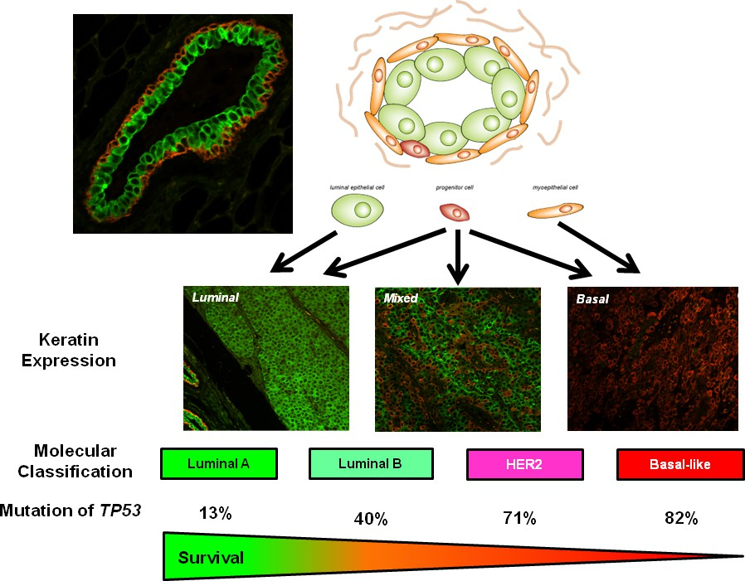Cancer Biology, Fall 2021 Syllabus

# ANIMLSCI 581H (Course# 10241) ANIMLSCI 697C (Course# 10215)

Days/Times: Tu/Th, 1:00 - 2:15 pm

Location: Morrill 1 N 347

Credit Hours: 3 (The class typically requires 2.5h of instructional time and ~6h of student time/week.)

**Instructors**:

D. <PROF_FULL_NAME> (ISB427P), Email: <PROF_EMAIL>, Tel: <PHONE>

<PROF_FULL_NAME> (ISB427J), Email: <PROF_EMAIL>, Tel: <PHONE>.

Office hours by appointment.

# Course description

We will cover changes in the prevalence of cancer and contemporary diagnostics and treatments. While these have dramatically decreased mortality, cancer continues to claim more than 585,000 lives annually. Therefore, the focus will be on the mechanisms that are corrupted in cancer cells and the differences in vulnerability among tissues, the technologies used to define pathways and lessons learned. Equally important are the strategies being used to exploit the vulnerabilities of tumors for personalized and targeted therapeutics. *PREREQUISITES: Students are expected to have completed courses in Molecular and Cellular Biology (Animlsci200, Biol285 or Biochem275) and Genetics (Animlsci311 or Bio283) with a grade of "C" or better or have Graduate Student status.*

# Textbook:

The Biology of Cancer, 2nd Edition; Author(s): Robert A. Weinberg; ISBN: 9780815342205

# Instructional goals and learning objectives:

Lectures will provide overarching concepts of cancer biology. The overarching concepts will provide the background needed for students to read and evaluate contemporary literature. Exams will provide an objective measure of overall understanding and will emphasize open responses to questions or problems. Final Projects will emphasize critical thinking and collaborative learning.

# Learning objectives

* + Develop skills related to the interpretation epidemiological studies of cancer to provide a context for evaluating factors that contribute to the process of carcinogenesis in humans.
  + Develop an understanding of the histopathological progression of cancer. This includes the cell types that are most susceptible to forming cancers and how they differ among tissues and organs.
  + Critically evaluate contemporary therapies and identify gaps.
  + Gain familiarity with the tools used to define the mechanisms disrupted in cancers. This will include the experimental approaches, comparative approaches to understand the differences in mechanisms and signaling underlying the spectrum of cancers and subtypes, and interpretation of data.
  + Understand pathways implicated in carcinogenesis from inherited genetic predisposition to cancers and contrast with effects of genetic variants identified in genome-wide association studies.
  + Critically evaluate emerging therapies and propose strategies to address the limitations and gaps in present treatments strategies.

Additional Resources:

Cancer Concepts: A Guidebook for the Non-Oncologist. Editors: Richard S. Pieters, MD and James Liebmann, MD; Associate Editor: Maryann Bishop-Jodoin, MEd; Assistant Editors: Jean Boucher, PhD, RN, NP; Andrew Chen, MD; Ediz Cosar, MD; Lisa A. Palmer, MSLS; Patricia Webster, MS, RT(T). Established

by the Department of Radiation Oncology and the Department of Medicine, Division of Hematology Oncology at the University of Massachusetts Medical School

<http://escholarship.umassmed.edu/cancer_concepts/>

Primary research articles will also be assigned as required readings. These will be provided electronically to students through MOODLE.

*Please note that lecture slides placed on MOODLE are the property of the instructors are not to be posted on secondary websites or otherwise shared without their consent. This pertains to in-class recordings as well. Posting materials online or via an outside vendor or entity without explicit permission of the instructors violates copyright laws as well as the academic honesty code. Violators are subject to expulsion.*

# Evaluation and Grading:

The exams will be based on the topics reviewed in class and will assess students’ understanding of basic concepts in cancer biology. The Final Projects will reflect students’ ability to read and interpret primary literature, experimental approaches and address critical questions.

* + 5% Class participation and homework assignments
  + 35% Exam 1
  + 20% Exam 2
  + 40% Final Projects --- ~15 double-spaced pages including figures. (References are not included in the page limits.

Grades are typically assigned using the following scale.

A ≥ 93.000 % | A− = 90.000-92.999 %

B+ = 87.000-89.999 % | B = 83.000-86.999 % | B− = 80.000-82.999% C+ = 77.000-79.999 % | C = 73.000-76.999 % | C− = 70.000-72.999 % D+ = 67.000-69.999 % | D = 60.000-66.999 %

F < 60.000 %

Written assignments will generally be submitted via Moodle and evaluated for appropriate referencing of sources.

**Students enrolled in Animlsci697C (Carcinogenesis)** have additional expectations **each week**.

* + - Review the Tables of Contents of two cancer-related journals. One should be JAMA Oncology. Access to articles is free by signing up.

See https://jamanetwork.com/journals/jamaoncology/currentissue.

* + - Select an article and submit a review each Monday morning via a GoogleDoc (link below). The submission should include the citation along with a brief summary of the article and your interpretation or questions. The GoogleDoc is shared with the class to provide a survey of literature for everyone as well as a source for class discussions.
    - Submit weekly reports at <LINK>

# 4. Class schedule for Fall 2019

|  |  |  |  |
| --- | --- | --- | --- |
| ***#*** | ***Date*** | ***Instructor*** | ***Topic*** |
| 1 | Th, Sept. 2 | <PROF_FULL_NAME> | Background on cancer (Chapters 1-2) |
| 2 | Tu, Sept. 7 | <PROF_FULL_NAME> | Cancer statistics (assigned readings) |
| 3 | Th, Sept. 9 | <PROF_FULL_NAME> | Introduction to epidemiology (assigned readings) |
|  | ***Assignment Tu, Sept. 14*** | ***Project Draft 1*** | ***Background/Epidemiology section for selected cancer (2 pages text & figures, excluding references)*** |
| 4 | Tu, Sept. 14 | <PROF_FULL_NAME> | Introduction to histopathology |
| 5 | Th, Sept. 16 | <PROF_FULL_NAME> | Contemporary chemotherapy (Chapter 16; pp797-812) |
| 6 | Tu, Sept. 21 | <PROF_FULL_NAME> | Viral oncogenes (Chapter 3) |
|  | ***Th, Sept. 23*** | ***Project Draft 2*** | ***Histopathology section for selected cancer*** |

|  |  |  |  |
| --- | --- | --- | --- |
|  |  |  | ***(2 pages text & figures, excluding references)*** |
| 7 | Th, Sept. 23 | <PROF_FULL_NAME> | Cellular oncogenes (Chapter 4) |
| 8 | Tu, Sept. 28 | <PROF_FULL_NAME> | Aberrant signaling in cancer (Chapter 5-6) |
| 9 | Th, Sept. 30 | <PROF_FULL_NAME> | Cell cycle (Chapter 8) |
| 10 | Tu, Oct. 5 | <PROF_FULL_NAME> | Tumor suppressors & inherited susceptibility (Chapter 7) |
| 11 | Th, Oct. 7 | <PROF_FULL_NAME> | Testing cancer pathways |
| 12 | ***Tu, Oct 12*** | <PROF_FULL_NAME> | ***Exam 1 (35% of grade)*** |
| 13 | Th, Oct. 14 | <PROF_FULL_NAME> | L1 - Introduction to immunology (I) |
|  | ***Oct 16*** | | ***Last day to drop with W and select P/F for undergraduates*** |
| 14 | Tu, Oct. 19 | <PROF_FULL_NAME> | L2 - Introduction to immunology (II) |
| 15 | Th, Oct. 21 | <PROF_FULL_NAME> | L3 - Tumorigenesis in the immune system |
| 16 | Tu, Oct. 26 | <PROF_FULL_NAME> | L4 - Tumor immunology |
| 17 | Th, Oct. 28 | <PROF_FULL_NAME> | L5 - Cancer immunotherapy |
|  | ***Oct 16*** | | ***Last day to drop with W and select P/F for undergraduates*** |
| 18 | ***Tu, Nov. 2*** | <PROF_FULL_NAME> | ***Exam 2 (20% of grade)*** |
| 19 | Th, Nov. 4 | <PROF_FULL_NAME> | Tumor heterogeneity --- from monolog to dialog Stem cells, microenvironment, epigenetics |
| 20 | Tu, Nov. 9 | <PROF_FULL_NAME> | Chemical carcinogenesis --- endogenous & exogenous  mutagens (Chapter 2, pp 60-66; Chapter 11, pp 480-484) |
|  | ***Th, Nov. 11*** | ***No classes*** | ***Veteran’s Day*** |
|  | ***Tu, Nov. 16*** | ***Project Draft 3*** | ***Intervention strategy section for selected cancer (2 pages text & figures, excluding references)*** |
| 21 | Tu, Nov. 16 | <PROF_FULL_NAME> | DNA repair & inherited cancer risk |
| 22 | Th, Nov. 18 | <PROF_FULL_NAME> | Mutational landscapes in cancers: searching for the “smoking gun” |
| 23 | Tu, Nov. 23  (Th schedule) | <PROF_FULL_NAME> | Emerging therapies---opportunities and challenges |
|  | ***Th, Nov. 25*** | ***No classes*** | ***Thanksgiving Break (Nov. 25-26)*** |
| 24 | Tu, Nov. 30 | <PROF_FULL_NAME> | Project presentations (3-4 students) |
| 25 | Th, Dec. 2 | <PROF_FULL_NAME> | Project presentations (3-4 students) |
| 26 | Tu, Dec. 7 | <PROF_FULL_NAME> | Project presentations (3-4 students) |
|  | Dec. 9, 11 | No class | Reading Period |
|  | ***W, Dec 15*** |  | ***Final Projects due at noon (40% of grade)*** |

1. **UMass Amherst academic regulations**

The UMass Amherst policy on class attendance is: “Students are expected to attend all regularly scheduled classes at the University for which they are registered. Students absent due to extenuating circumstances- including jury duty, military obligations, scheduled activities for other classes, the death of a family member, or verifiable health-related incapacity-remain responsible for meeting all class requirements and contacting the faculty member in a timely fashion about making up missed work. Faculty shall offer such students reasonable assistance in making up missed classes.”

Detailed consideration of these regulations can be found at the website for the University Registrar. (https://[www.umass.edu/registrar/students/policies-and-practices/academic-regulations)](http://www.umass.edu/registrar/students/policies-and-practices/academic-regulations)) as well as the ***Academic Regulations***, an annual publication of the Office of the Provost.

# Accommodation:

The University of Massachusetts Amherst is committed to providing an equal educational opportunity for all students. If you have a documented physical, psychological, or learning disability on file with Disability Services (DS), you may be eligible for reasonable academic accommodations to help you succeed in this

course. If you have a documented disability that requires an accommodation, please notify me within the first two weeks of the semester so that we may make appropriate arrangements.

# Ownership of course materials

Many of the materials created for this course are the intellectual property of the instructor. This includes, but is not limited to, the syllabus, lectures, problem sets, exams, study guides, and course notes. Except to the extent not protected by copyright law, any use, distribution or sale of such materials requires the written permission of the instructor. Please be aware that it is a violation of university policy to reproduce, for distribution or sale, course material including the syllabus, lectures, problem sets, exams, study guides, and course notes.

# Academic honesty policy (URL: https://[www.umass.edu/honesty/)](http://www.umass.edu/honesty/))

The academic enterprise of any institution of higher education requires honesty in scholarship and research. Therefore, academic honesty is required of all students at the University of Massachusetts Amherst. Academic dishonesty is prohibited in all programs of the University. Academic dishonesty includes but is not limited to: cheating, fabrication, plagiarism, and facilitating dishonesty. Appropriate sanctions may be imposed on any student who is found to have committed an act of academic dishonesty. Instructors should take reasonable steps to address academic misconduct. Any person who has reason to believe that a student has committed academic dishonesty should bring such information to the attention of the appropriate course instructor as soon as possible. Instances of academic dishonesty not related to a specific course should be brought to the attention of the appropriate department Head or Chair. The procedures can be found on the website listed above. These are intended to provide an efficient and orderly process by which action may be taken if it appears that academic dishonesty has occurred and by which students may appeal such actions. Since students are expected to be familiar with this policy and the commonly accepted standards of academic integrity, ignorance of such standards is not normally sufficient evidence of lack of intent.